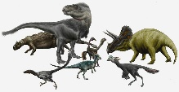
Online Home Learning Grid - Week beginning 18.1.2021 – Year 2
- Here is your home learning grid for Week 3. We will be continuing our new topic all about Dinosaurs.
- Remember, if you have ANY questions, remember your teacher is there to help! Send them a message - your parents will be able to help you write an email!
Mrs Watson’s email address is lwatson@brunelprimary.co.uk
- Also, if you want to share your learning with us or show us something you’ve been up to, you can email me and I will be able to respond and give you feedback! We are expecting you to email at least one piece of English, Maths and Theme work every week. These will be highlighted in yellow on the home learning grid so you know which activities you must have completed and sent to us. Just take a photo and send to my email address. Alternatively if you would like to send what you do daily then that would also be great, or send it in one email at the end of the week on a Friday if that’s easier.
- Remember to check you class blog daily for updates and videos and resources you may need to access at https://www.brunelprimary.co.uk/Class/Kingsand
- 4.
 | Monday | Tuesday | Wednesday | Thursday | Friday
Phonics every day:  Watch the daily Read Write Inc videos at https://www.youtube.com/channel/UCo7fbLgY2oA_cFCIg9GdxtQ  Remember to record your spellings and hold a sentence in your pink book or in your own notebook/or on paper. | All lessons are online at 9.30am on the RWInc Youtube Channel and stay up for 24 hours so you can access at a time to suit you.  For Set 1 Sounds – you will need to watch the speed sounds lesson, word time reading lesson and do set 1 spelling.  For Set 2 Sounds – you will need to watch the set 2 speed sounds session and then do the spelling session.  For Set 3 sounds – you will need to watch the set 3 speed sound session and then do the spelling session.  You can also scroll down the page of videos to find:  Read Red Words Videos – choose either Lesson 1 or 2  Read and Hold a Sentence videos - choose either Lesson 1 or 2  For those of you on Set 3 sounds – you can access the Read Longer Words videos as well
Spellings | Practise your spellings daily.  You will find your spellings as a pdf document on the blog. Follow the instructions at the top of the page in the pdf. |  |  |  | Spelling Test!  Record your spelling test in the BACK of your pink book or notebook you’re using at home.
Handwriting  We will be learning to write pre-cursive letters as this will make joining your letters much easier when we return to school.  Please practice your handwriting in your pink books at home or in a notebook. Make sure you are practising on lines.  We would also like you to practise writing the long date each day. Get an adult to write it for you and then you can copy it into your pink book before doing your handwriting practice.  e.g. Monday 18th January | Practise forming a pre-cursive  ‘g’  Use this video to guide you through it and write a line, or more of g’s.  https://www.youtube.com/watch?v=GPIywbNhias  Then practise your capital G. Notice on the video how it still sits on the line but it taller and touches the top line.  https://www.youtube.com/watch?v=Be7fNiJTSjg | Practise forming a pre-cursive  ‘s’  Use this video to guide you through it and write a line, or more of s’s.  https://www.youtube.com/watch?v=Z88An0KpuYo  Then practise your capital S. Notice on the video how it still sits on the line but it taller and touches the top line.  https://www.youtube.com/watch?v=MMCCbGPmhq8 | Practise forming a pre-cursive  ‘q’  Use this video to guide you through it and write a line, or more of q’s.  https://www.youtube.com/watch?v=clmk9BMcdEg  Then practise your capital Q. Notice on the video how it still sits on the line but it taller and touches the top line.  https://www.youtube.com/watch?v=Tn7zYwHqb-A | Practise forming a pre-cursive  ‘f’  Use this video to guide you through it and write a line, or more of f’s.  https://www.youtube.com/watch?v=7U3d_yiX81M  Then practise your capital F. Notice on the video how it still sits on the line but it taller and touches the top line.  https://www.youtube.com/watch?v=o_AsYjLVJ6w | Practise all the letters we have learned this week by writing the following words:  got  Gareth  sat  Saltash  quick  Queen  flag  France  Can you think of any other words containing our letters from this week?
Reading every day  This could be a book of your choice or there are lots of exciting e-books on Oxford Owl. Log-in here. You will be able to find books that are in line with your book band colour just like the ones you’ve been taking home in your bookbag.  https://www.oxfordowl.co.uk/login?active-tab=students  Stick to the 3 day reading cycle – so re-read your oxford owl e-book 3 times to build your fluency before moving on to the next book.  OxfordOwl Login Username: kingsand brunel  Password: brunel  Don’t forget the space in between kingsand and brunel on the username! | Story time  CBeebies Bedtime stories – all your favourite celebrities reading stories for you!  https://www.bbc.co.uk/iplayer/episodes/b00jdlm2/cbeebies-bedtime-stories | Class blog story  Check your class blog at www.brunelprimary.co.uk to find a story read by your teacher! Or why not have a go at recording your own and sending it to me? | Class blog story  Check your class blog at www.brunelprimary.co.uk to find a story read by your teacher! Or why not have a go at recording your own and sending it to me? | Class blog story  Check your class blog at www.brunelprimary.co.uk to find a story read by your teacher! Or why not have a go at recording your own and sending it to me? | Story time  Choose a story to watch and listen to being read at this great website: https://www.storylineonline.net/

 | Monday | Tuesday | Wednesday | Thursday | Friday
English  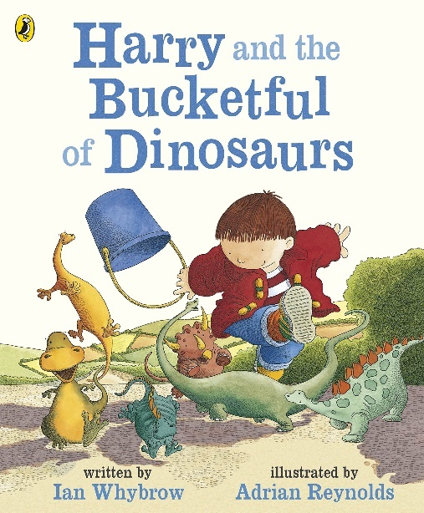 | Guided Reading  Fact- Finders  Use the fact finders sheet or write the features you are looking for into your exercise book.  Then Read through the ebook pdf (with a little grown up help if you need it) and write down the page number when you find that feature.  Write a sentence to tell us which illustration was your favourite? Can you use ‘because’ to explain why you like it? | Create your own story plan  Watch today’s lesson video on the blog.  Today you are going to be planning your own version of Harry and the bucket full of dinosaurs. You will need to decide on:  -New characters  -Objects to be found  -Where the objects are found  -Where the characters go  -How they get there  -Where they lose their objects  -How they find the objects again  -Who helped them find them  When you have decided on all of these features you can come up with a new title for your story.  You can use the example story map to help you come up with ideas. You can use the planning sheet to write on or write or draw all your ideas into your exercise book. | Rehearse your story  Watch today’s lesson video on the blog.  Rehearse your story with an adult – create actions to remember your sentences to write your own lost and found story based on the story mountain plan you created yesterday.  Think carefully about where your full stops should go and remember to punch the air when you need one when doing the actions!  Remind yourself of the beginning, middle and end of your story ready for writing tomorrow.  Make sure you are including adjectives to describe, lots of ambitious vocabulary and Time adverbs to show the order of your sentences. | Write story  Watch today’s lesson video on the blog.  Today you will be writing your own lost and found story that you rehearsed yesterday using your story plan.  Remember to rehearse each sentence before writing it in your English book.  Remember to use:  - Capital letters  - Finger spaces  - Full stops  - Time adverbs  (eg. Suddenly, A while later)  - Powerful vocabulary  (eg. Adjectives)  Challenge: Can you use the conjunction ‘because’ to join two sentences?  Make sure your story has a beginning, a middle and an end.  Please send a photo of your finished writing via email to me. | Finish/ Edit and Improve  Spend today:  - Finishing off your story if you haven’t already  - Read it out loud to an adult in a clear speaking voice.  - Go through the success ladder on the blog together with an adult – what have you done well, what do you need to improve?  Ask your child to tell you the symbols we use for marking how well they’ve done on the success ladder – they should remember!  - If you have not spelt certain words correctly – have a go at writing these out 3 times each to practise for next time.  Challenge: Can you copy your story up with illustrations and neat handwriting to show off your writing!

 | Monday | Tuesday | Wednesday | Thursday | Friday
Maths  Visit https://whiterosemaths.com/homelearning/year-1/  Go to Spring Week 1 – Number: Addition and subtraction (within 20)  Watch the learning video for each day. Worksheets to go with the video lessons can be found on our class blog underneath the top post to follow or print off or you can just complete what the worksheets tell you in your Maths book or on paper.  To access MathShed using your log-ins at the back of your monkey book (your reading record)  https://www.mathshed.com/en-gb/  We will be uploading assignments/games/quizzes for you to complete during the week.  99 Club  Remember - when you get 3 sets of your club sheets correct in a row we can move you up to the next level. Email me to ask to check when you can do this. | Starter Activity  Practise counting up and back to 100.  If that’s too easy: Can you challenge yourself and count up and back to beyond 100? | Starter Activity  Can you write down the answers to these questions involving missing numbers? Can you time yourself?  1 + = 10, 2 + = 10,  3 + = 10, 4 + = 10,  5 + = 10, 6 + = 10,  7 + = 10, 8 + = 10,  9 + = 10, 10 + = 10  Challenge: Can you write them with the equals at the start?  e.g. 10 = 7 + 3 | Starter Activity  Can you write down all the different subtraction facts for 10?  e.g. 10-9=, 10-8=  Challenge: Can you write them with the equals at the start?  e.g. 3 = 10 - 7 | Starter Activity  99 club – set yourself a timer for 10 minutes and see how many of the questions you can complete. | Starter Activity  Can you count in 5s to 100?  And back again?  You could watch this video and join in for counting up: https://www.youtube.com/watch?v=amxVL9KUmq8  You could watch this video and join in for counting back:  https://www.youtube.com/watch?v=PTePHopMI5U
 | Spring Term  Week 2  Lesson 1  Use Arrays | Spring Term  Week 2  Lesson 2  Make Doubles | Spring Term  Week 2  Lesson 3  2 Times Tables | Spring Term  Week 2  Lesson 4  5 Times Table  Please send a photo of your finished maths via email to me (this does not have to be on the sheet, it can just be a photo of your answers in your maths book) | Spring Term  Week 2  Lesson 5  10 Times Tables
 | MathShed Task  Log-in to find a quiz/task for you to practise using arrays | MathShed Task  Log-in to find a quiz/task for you to practise making doubles | MathShed Task  Log-in to find a quiz/task for you to practise your 2 times tables | MathShed Task  Log-in to find a quiz/task for you to practise your 5 times tables | MathShed Task  Log-in to find a quiz/task for you to practise your 10 times tables

 | Monday | Tuesday | Wednesday | Thursday
Theme / Free Choice  Do on the days stated or just pick and choose throughout the week!  There are also lots of episodes of Andy’s Prehistoric Adventures on BBC IPlayer which will inform your child even more about dinsoaurs!  Go to:  https://www.bbc.co.uk/iplayer/episodes/p03hc1rn/andys-prehistoric-adventures | Science  What is a living thing?  Use the link below or go to the Oak National Academy website then click ‘find lessons’, ‘Key Stage 1’, ‘Science’, ‘The Animal Kingdom’ ‘What is a living thing?’  https://classroom.thenational.academy/lessons/what-is-a-living-thing-70t3ae?activity=video&step=1  We are going to be scientists studying what living and non living means. We will need to use this key vocabulary for this lesson.  living  waste  reproduce  survive  feeding  growing  air  You will also learn a little about different diets. You will be learning about these words:  carnivore  herbivore  omnivore  You will need to copy the labels and sentences into your English/Theme Book or onto a piece of paper and fill in the missing words. | Science  Dinosaur diets  Use what you learned about Carnivores, Herbivore and Omnivores yesterday to help with learning about Dinosaur diets.  Go through the PowerPoint to find out what diets different dinosaurs have. Then use this knowledge to sort the dinosaurs (you can just write their names if you prefer) into the correct part of the Venn diagram. You can use the sheet on the blog or draw it into your English/Theme exercise book.  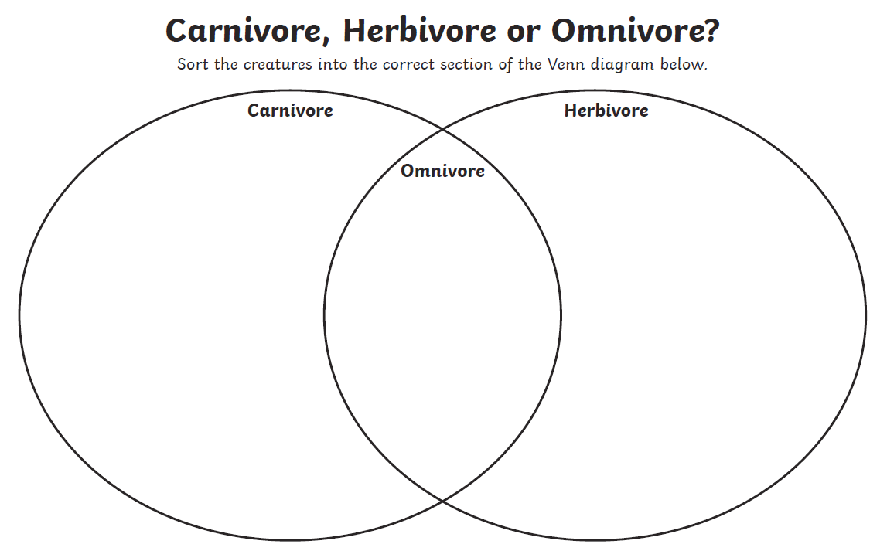  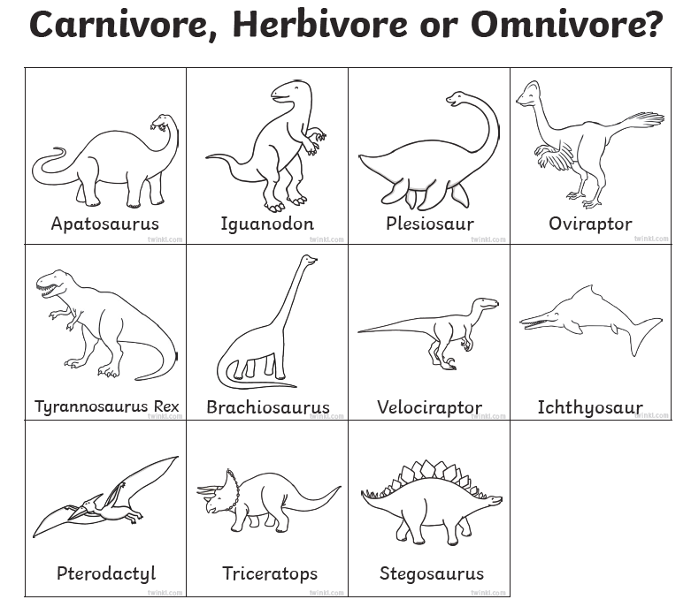 | History  How is a dinosaur fossil made?  Maddie and Greg explain how fossils are made and speak to a fossil expert. You can become a Palaeontologist and find out about excavating and the roar-some world of Dinosaurs!  Watch the video here:  https://www.youtube.com/watch?v=-qe89q8YYF0  See if you can have a go at some of the activities they suggest!  You will find all the equipment lists and resources in the description below the video should you want them. | PE –  Joe Wicks is back with his daily workouts!  https://www.youtube.com/c/TheBodyCoachTV/featured  Have a go at home and don’t forget to get outside for your daily exercise with your family each day.  Winter Olympics!  Have fun at home recreating a sport from the Winter Olympics. This week we’d like you to have a go at bob-sleigh!  Can you research what bob-sleigh is and how to do it? How many people in a team? Can you make a poster about bob-sleigh and email it to your teacher?  Watch Mrs. Watson and Miss Wood have a go at recreating the bob-sleigh! Can you have go at home and send us a video? Even a big cardboard box in your living room could work, or sit in a washing basket and pretend?
 | RE:  We are going to think about FORGIVENESS this week.  Christians believe that we should forgive others because God has forgiven us for the wrong things we do.  Talk with your adult – what does it mean to forgive? Accepting someone’s apology when they have said sorry for hurting you.  Watch this video to find out more about forgiveness:  https://www.youtube.com/watch?v=FFuHL6Izk6E  Now go through the pdf about being sorry and accepting someone’s apology on the blog with your adult and talk through each of the slides together. | Art/DT:  Go and find a range of different pens and pencils to have a go at using them in different ways to create different patterns and effects.  e.g. writing pencil, coloured pencils, felt tip pens, a biro, markers, wax crayon  You will need 2 sheets of A4 paper as well.  We are going to practise hatching, scribbling, stippling and blending.  Go to the blog and watch Miss Wood’s video for what to do with your different pens to try out different techniques for shading/colouring and drawing. | Music  https://classroom.thenational.academy/lessons/creating-simple-patterns-6rwk8d  In this lesson, we will be learning about creating patterns using our bodies.  https://www.youtube.com/watch?v=BQ9q4U2P3ig  Sing and move along with this song! | Computing –  Find out how computers help us to learn:  https://www.bbc.co.uk/bitesize/topics/zymykqt/articles/zxbwjxs  Ask an adult to read the information to you and then you can play the game.  Find out: What is the internet? Read the information and watch the video.  https://www.bbc.co.uk/bitesize/topics/zymykqt/articles/zgwnsbk

