**Science**

Movement of the Earth, Moon and Sun.

Explain day and night.

Explain how light travels in straight lines.

How and why shadows are formed.

**RE/PSHE**

Creation or science: conflicting or complimentary?

Dreams and goals

**Art**

Creating papier mache planets (spheres) with facts

**Maths**

Diameter of planets

Distance from the Sun etc.

Ordering sizes

Data collection and graphs

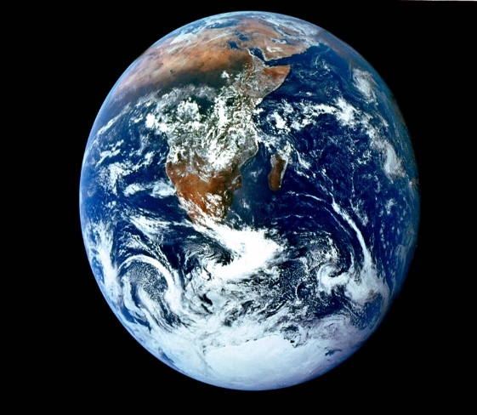

**History**

Timelines of space events.

Differences of future and reality.

**MFL - French**

Planet names

Size and ordering language

**Geography**

Aerial photographs and maps.

Using databases to collect data

Displaying data in graphs and charts.

Locating space events on a map.

**How Fast are we Moving Right Now??**

**Music**

Appraising music

Composing music in groups

Notation

**English**

Time travel story

Newspaper report (Alien invasion)

Space Poems

Computing

Use a database to collect data.

Create graphs and chart using Excel.