Would you Like to Live in the Desert? Summer Term 1 2025 |  |  |  | Year 5
English  Narrative (Traditional Tales):  - Know how to structure a narrative.  - Know how to use dialogue to advance the action.  - Know how to punctuate speech accurately.  - Know how to use archaic language for effect. | Science  Animals, Including Humans  - Know the key stages of a mammal’s life cycle.  - Know the gestation periods of mammals.  - Know about foetal development.  - Know how to investigate the hand span of differently aged children.  - Know about the changes experienced in puberty.  - Know the changes humans may experience during old age. | 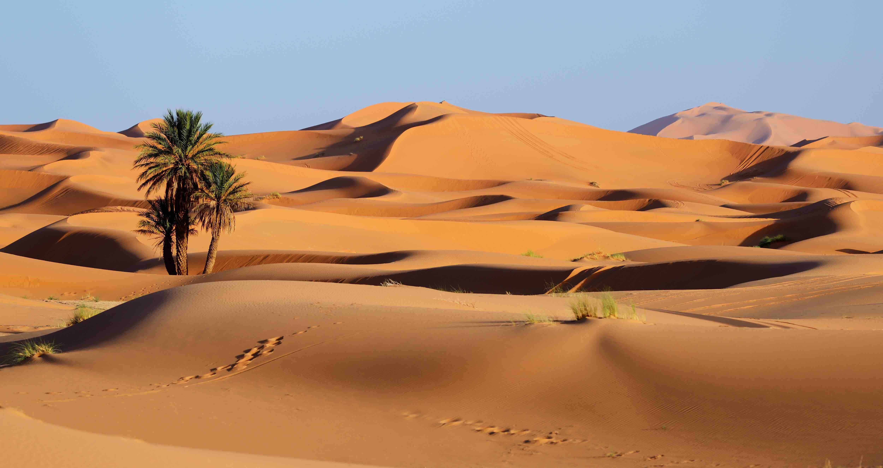    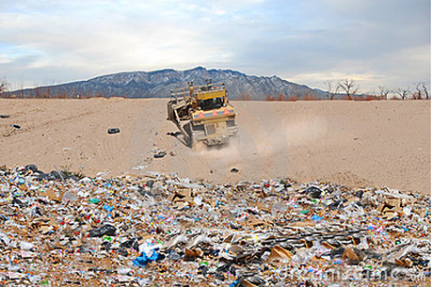 | Geography  - Know the characteristics of a desert biome.  - Know how to locate and explore features of deserts.  - Know how to describe the physical features of a desert environment.  - Know the different ways humans can use deserts.  - Know some of the threats facing deserts.  - Know the similarities and differences between two physical environments. | P.S.H.E.  Relationships  - Know who I am as a person in terms of my characteristics and personal qualities.  - Know that belonging to an online community can have positive and negative consequences.  - Know there are rights and responsibilities in an online community or social network.  - Know there are rights and responsibilities when playing a game online.  - Know when I am spending too much time using devices (screen time).  - Know how to stay safe when using technology to communicate with my friends.
Key Vocab:  Dialogue, inverted commas, causal conjunctions, modal verbs, prepositions, adverbs, adverbials, nouns, verbs, tenses | Key Vocab:  Offspring, foetus, dependent, adolescent, puberty, gestation, pregnant, toddler, prenatal, breeding, embryo, hormones |  | Key Vocab:  Agriculture, arid, biome, desert, drought, mesa, airstrip, barren, climate, desertification, flash flood, mining | Key Vocab:  Rights, responsibilities, belonging, online safety, addiction, healthy, risk, harm
Art/D.T.  DT  Structures (Playgrounds):  - Know how to design a playground with a variety of structures.  - Know how to build a range of structures.  - Know how to improve and add detail to structures.  - Know how to create a surrounding landscape. | Computing  Vector Drawing:  - Know that drawing tools can be used to produce different outcomes.  - Know how to create a vector drawing by combining shapes.  - Know how to use tools to achieve a desired effect.  - Know how to recognise that vector drawings consist of layers.  - Know how to group objects to make them easier to work with.  - Know how to apply what I have learned about vector drawings. | Music  Charanga: Dancing in the Streets  - Know a song from memory, who sang them and when they were written.  - Know some style indicators of the song.  - Know the names of some instruments found in the song.  - Know music dimensions for the song.  - Know how to recognise connection between sounds and symbols.  - Know how to perform with confidence. | R.E.  Why do Hindus Try to be Good?  - Know the correct vocabulary to express views about Hindu belief in Brahman.  - Know an accurate written definition of atman.  - Know how to define karma, samsara, dharma and moksha.  - Know how belief in dharma and ashramas might impact the way that a Hindu lives their life.  - Know how a Hindu, wo believes in samsara, karma, dharma and moksha, might live their life. | French  Clothes  - Know the vocabulary for a variety of clothes in French.  - Know how to use the appropriate genders and articles for these clothes.  - Know how to use the verb porter in French with increasing confidence.  - Know how to say what they wear in different weather/situations.  - Know how to describe clothes in terms of their colour & apply adjectival agreement.  - Know how to use possessives with increased accuracy.
Key Vocab:  Apparatus, design criteria, equipment, playground, landscape features, cladding | Key Vocab:  Vector, group, objects, moving, resizing, rotating, manipulating, drawing | Key Vocab:  dynamics, verse, chorus, texture, tempo, rhythm, pitch, pulse, timbre, notation, structure | Key Vocab:  Brahman, atman, dharma, samsara, moksha, karma, | Key Vocab:  (See vocab list in books)

