  What is a monarch? Summer Term 1 2025 |  |  |  | Year 1
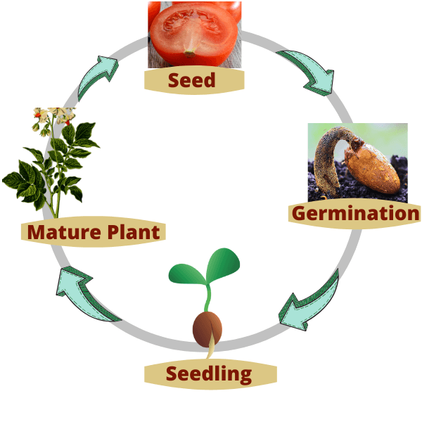  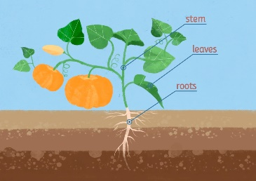 | Science  Plants  Know how to identify and name a variety of common wild and garden plants, including deciduous and evergreen trees.  Know how to identify and describe the basic structure of a variety of common flowering plants, including trees.  Know how to observe and describe how seeds and bulbs grow into mature plants.  Know how to find out and describe how plants need water, light and a suitable temperature to grow and stay healthy. | History  Monarchs  Know that a monarch is a king or queen.  Know that recent monarchs in the UK do not have the power to make decisions alone.  Know some of the monarch’s roles.  Know that a king or queen is crowned in a special ceremony called a coronation.  Know some of the main steps in the coronation ceremony and the use of special objects in the coronation.  Know how to use sources to explain how became King of England.  Know that monarchs in the past had all the power to make decisions.  Know the two different types of castles built by the Normans and their features.  Know how castles have changed over time.  Know characteristics of the monarchy in the past.  Know that the monarchy has changed over time.  Know how to comparisons between past and present monarchy. | 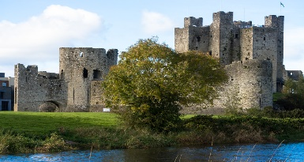  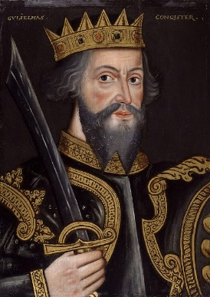  This Photo by Unknown Author is licensed under CC BY-SA | PE  Striking and Fielding  Know how to throw and catch a ball from a partner (catching it most of the time.)  Know how to aim a ball at a target and hit it some of the time.  Know how to vary the way I bowl a ball at a target.  Know how to hit a ball (with a bat) when it is bowled towards me.  Know how to use the skills I have learned to bowl, roll, throw, catch and hit a ball in a small game situation.
 | Key Vocab:  leaf, flower, blossom, petal, fruit, berry, root, seed, trunk, branch, stem, bark, stalk, bud, light, shade, sun, warm, cool, water, grow, healthy, germinate | Key Vocab:  king monarchy power queen ruler |  | Key Vocab:  catch, hit, accurately, throw, bowl, roll
Art/DT  Textiles: Puppets  Know how to join fabrics together using pins, staples or glue.  Know how to design a puppet and use a template.  Know how to join two puppets’ faces together as one.  Know how to decorate a puppet to match their design. | Computing  Creating Media  Know how music can make us feel.  Know how to identify that there are patterns in  music.  Know how to experiment with sound using a  computer.  Know how to use a computer to create a musical  pattern.  Know how to create music for a purpose.  Know how to review and refine our computer work. | Music  Know how to listen and clap back, then listen and clap your own answer (rhythms of words).  Know how to use voices and instruments, listen, and sing back, then listen and play your own answer using two notes, with G moving to E.  Know to take it in turns to improvise using E, G, A and B. | R.E.  Who do Christians say made the world?  Know that ‘Creation’ is the beginning of the ‘big story’ of the Bible.  Know the story of creation from Genesis 1:1–2.3 simply.  Know what the story tells Christians about God, Creation and the world.  Know what Christians do to say thank you to God for the Creation.  Know at least two examples of what Christians do to look after the world for God. | P.S.H.E.  Relationships  Know how to identify the different members of my family, understand my relationship with each of them.  Know that there are lots of forms of physical contact within a family.  Know how to identify some of the things that cause conflict with my friends.  Know that sometimes it is good to keep a secret and sometimes it is not good to keep a secret. Know how to recognise and appreciate people who can help me.
Key Vocab:  Decorate, design, fabric, glue, model, hand puppet, safety pin, staple, stencil, template | Key Vocab:  information technology, digital photography, self-image, identity, online, relationships, computer | Key Vocab:  sequence, tapping, scraping, body percussion, chime, chord, compose, duration, percussion | Key Vocab:  creation, create, Earth, Genesis, Old Testament, bible, God, praise | Key Vocab:  Family, friends, relationship, community, appreciate

